STATELINE OFFICIALS ASSOCIATION SUMMER SCHOOL
3-Person Mechanics Camp
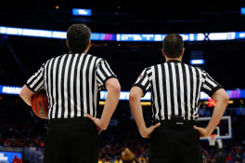June 12, 2026
Monona Grove High School $75/camper
$45/college student
WIAA Certified Camp
Must be able to attend the Full Day of Camp.
Classroom + Games
Time: 12-8pm
There is a potential for a Thursday night classroom for attendees that need 3-person classroom time.
Credit for Camp is detailed on the WIAA website.

NAME:
ADDRESS:
CITY:
ZIP:
EMAIL:
PHONE:
WIAA #:
YEARS OFFICIATING BASKETBALL:
I, the undersigned, do hereby acknowledge the potential risks involved with participation in this event. I am aware that the STATELINE OFFICIALS ASSOCIATION, MONONA GROVE HS, OR the facilities used do not provide insurance and cannot assume responsibility for injury. All refund requests must be submitted in writing. If your request is received more than 30 days before the camp begins, you will be charged a $50 administration fee. Requests received less than 30 days before camp begins will not be eligible for refund.
SIGNATURE/DATE:
____________________________________
CHECK PAYMENT PAYABLE TO:
STATELINE OFFICIALS ASSOCIATION
Venmo mike_pfeil_3

Email form to statelineofficialsassociation@gmail.com
or mail to:
Mike Pfeil, 78 Campion Dr., Evansville, WI 53536

